LAB # 03
Working with MS- POWERPOINT

Introduction
Microsoft PowerPoint is a slide show presentation program currently developed by Microsoft. PowerPoint initially named "Presenter", was created by Forethought Inc.. Microsoft's version of PowerPoint was officially launched on May 22, 1990, as a part of the Microsoft Office suite. PowerPoint is useful for helping develop the slide-based presentation format and is currently one of the most commonly-used presentation programs available.
EXAMPLE # 01: Using PowerPoint to create a presentation
Create a Power point presentation as specified:
- Title page
  - Slide Layout should be “Title Slide”
  - Heading: “Communication Media”
  - Add your name in a Text Box. Centered at the bottom of the slide
- First slide
  - Slide Layout should be “Title and Content”
  - Title: “Types of Communication Media”
  - Text: Wired and Wireless (In bullets)
  - Place picture in front of each type
- Second slide
  - Title: “Wired”
  - Define Wired Communication Media (In Bullets)
  - Write Examples: Telephone Network, Cable Television, Internet Access, Fiber-Optic communication, Wave guide
- Third Slide – Seventh Slide
  - Title: “Example Of Wired Communication Media”
  - Define Telephone Network, Cable Television, Internet Access, Fiber-Optic communication, Wave guide
  - Add one picture and at least three points about each example
- Fourth Slide
  - Title: “Wireless”
  - Define Wireless Communication Media(In Bullets)
  - Write Examples: Infrared, Microwave, Bluetooth, Communication Satellite, Radio Transmission
- Fifth Slide – Thirteenth Slide
  - Title: “Example of Wireless Communication Media”
  - Define Infrared, Microwave, Bluetooth, Communication Satellite, Radio Transmission
  - Add one picture and at least three points about each example
- Sixth Slide
  - Create a Summary
- The background color of each slide should be different
- Add transition to all slides (Same for all slides)
- Add animations to the text
  - Apply “Fade” animation for the title of each Slide
  - Apply any other animation on the remaining text

Example # 02: Using Action Buttons to create a nonlinear presentation
Create a Power point presentation as specified:
- Make a simple four-slide show.
- Use the Title Only layout and move the title to the middle of the slide.
- Place a title on each slide corresponding to the number of the slide (Slide One, Slide Two...).
- Give each slide background a different color.
- SLIDE 1:
  - Add a button in the bottom right corner of this slide to allow us to jump to slide two.
- SLIDE 2:
  - Add a button in the bottom right corner of this slide to allow us to jump to slide three.
  - Create a button in the bottom left corner of this slide to go back to slide one.
- SLIDE 3:
  - Add a button in the bottom right corner of this slide to allow us to jump to slide four.
  - Create a button in the bottom left corner of this slide to go back to slide two.
  - Add a third button in the middle at the top of the slide. This will be a hyperlink to an Internet page.
- SLIDE 4:
  - Insert a button in the middle of this slide, back to the first slide. Choose the button with a house on it, as a link to the Home slide.

Example # 03: Using Invisible Buttons in a PowerPoint Slide Show
Create a Power point presentation as specified:
- Find a good picture that has elements that you want to feature in your PowerPoint show.
- On the first slide, insert the picture you plan to use and resize it so the picture covers most, or all, of the slide.
- Identify how many action buttons you have to add in the slide. Add the same number of slides in your show.
- Put something in the title area of each slide to identify the content of the slide. (You will need these titles to link your action buttons to the slides)
- Over each picture, place action buttons that will direct the viewer to a slide about that picture.
- Next make the buttons invisible.
On each of the slides other than the picture slide, you should place a button to allow someone to return to the home page.
Example # 04: Animate PowerPoint Slide named Sparkle
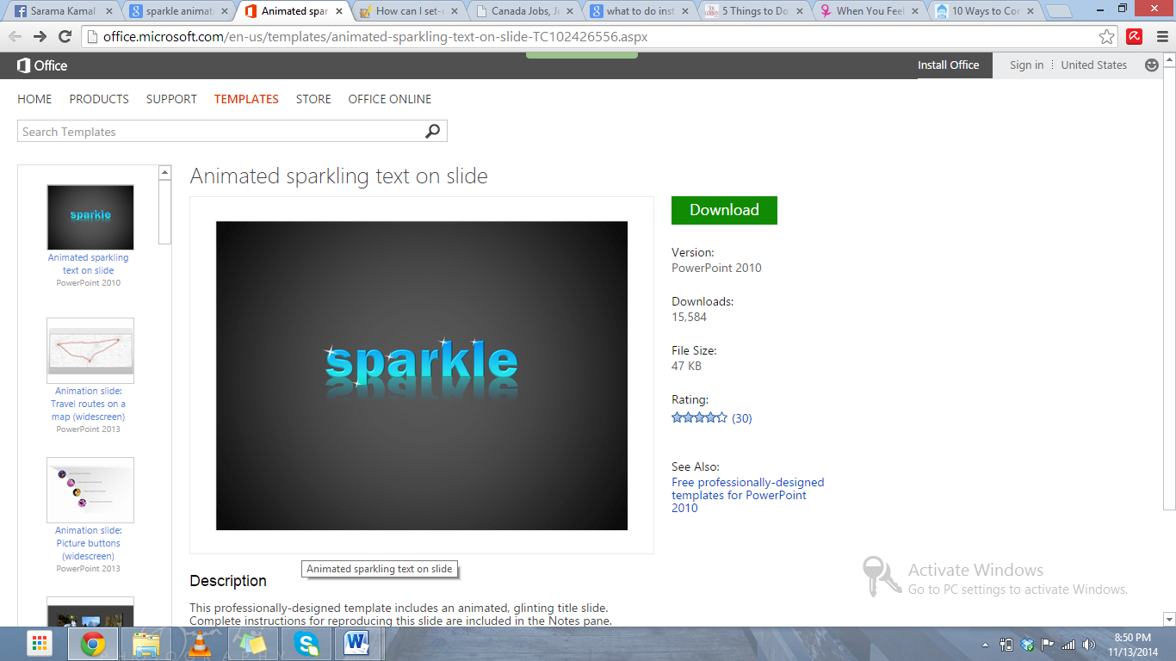

Lab Tasks
Task # 01: Create a PowerPoint presentation with Title “My Software Product”, include the transitions, animations, images and the following headings should be included in the slides:
  - Problem statement
  - Existing system
  - Features
  - Hardware Requirements/ Software Requirements
  - Drawbacks

Task # 02: Create a PowerPoint presentation with Title “Dives Visualization”, and add the following features:
- On slide 2 add a column chart that shows the following information:
Location | Number of Dives  this Year
Red Sea | 1780
Caribbean | 3280
Thailand | 3387
Hawaii | 2472
Belize | 1398
- Make sure that the chart also includes the following:
  - The heading ‘Best Places to Dive’.
  - Horizontal axis label of ‘Location’. Vertical axis label of ‘Number of Dives this Year’.
  - The legend should be removed.
- Position the chart in the space below the text ‘This chart shows the best places to dive:’.
Save the presentation.

